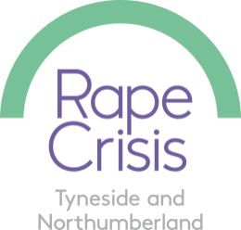

FULL-TIME/PART-TIME COUNSELLOR WORKER (TYNESIDE)

PART-TIME COUNSELLOR WORKER (NORTHUMBERLAND)
Funded for 8/9 months depending on start date including:

- Range of Full time & Part Time positions for Tyneside – Newcastle central (and 1 day/week in South Tyneside)

- 18.5 hr post – Northumberland bases

FTE £27741 gross
NJC pt 23

We require an experienced female counsellor to join our growing counselling service. You must have experience of working with women and girls 13+ who are survivors of any form of sexual violence, at any time in their lives. You must be BACP or UKCP Accredited or be working towards accreditation. Experience of telephone or online counselling is desirable. We have a range of roles, delivering face-to-face counselling in our central office in Newcastle, and a 1 day per week at an outreach base in South Tyneside. We also have an 18.5 hr post in Northumberland covering a range of outreach bases.
The ability to manage a caseload, hold clear boundaries with clients and services and keep accurate client records is essential. We require someone who with excellent communication and team working skills who can work within the spirit of RCTN’s values and ethos and adhere to Rape Crisis National Service Standards. The post requires the successful candidate to work flexibly, with a mixture of home-working for all admin and non-face-to-face based tasks and building-based working for face-to-face counselling. The post may require some evening sessions.
Please note, there may some limited opportunities to deliver online/telephone from home.
Please see job description/person specifications
Deadline for applications is Monday 14th June 2021 at 12 noon.
Interviews will be held on Wednesday 16th and Thursday 17th June 2021.
For more information contact hstephan@rctn.org.uk
To download application, job description & person specification:

Female applicants only: Schedule 9 (paragraph 1) of the Equality Act 2010 applies

