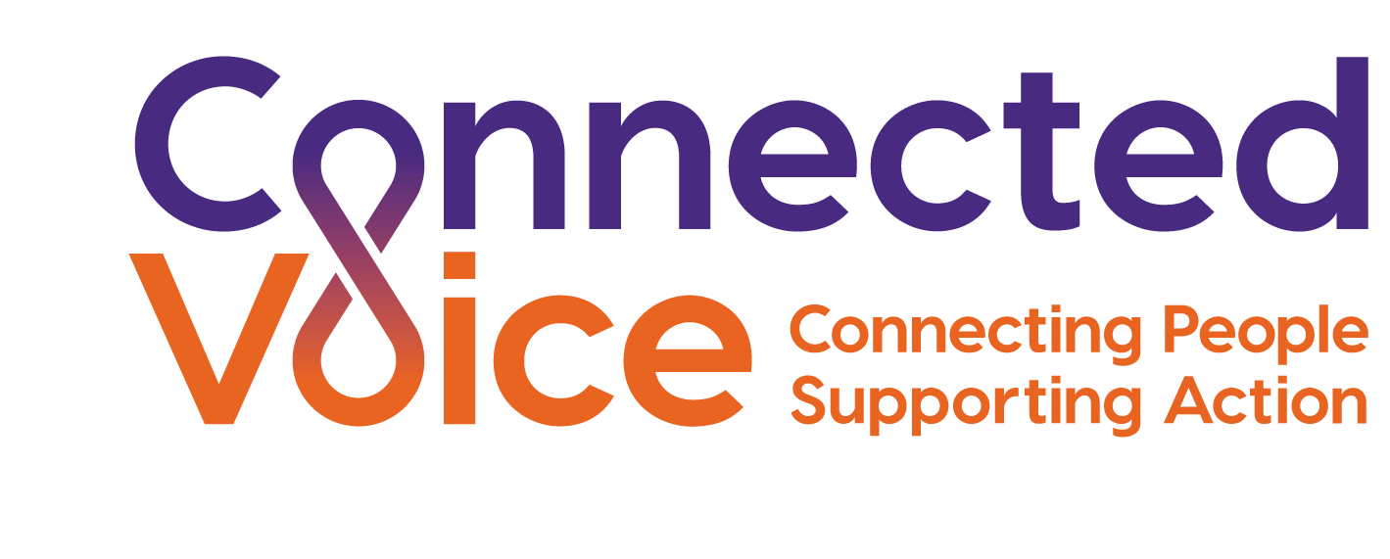

RECRUITMENT OF EX-OFFENDERS POLICY

Connected Voice aims to promote equality of opportunity for all, and therefore welcomes applications from ex-offenders who are appropriately qualified to do any of our jobs. Criminal records are only taken into account when the conviction is relevant to the job.

Unless the nature of the work demands it, you will not be asked to disclose any convictions which are “spent” under the Rehabilitation of Offenders Act 1974. Having an unspent conviction will not necessarily bar you from employment. This will depend on the circumstances and background to your offences, and the degree of risk that we judge that it carries.

Some posts at Connected Voice are judged to require a Disclosure and Barring Service (DBS) check, because of the nature of their work. When this is the case, applicants will be warned that a DBS check will be sought.

With posts for which DBS checks are not required, forms requesting information on “unspent” convictions will be asked only of short listed candidates. Connected Voice requests honesty in this situation since it needs to consider all elements of candidates’ suitability, but will make every effort to give ex-offenders a fair chance.

All information about criminal convictions given to Connected Voice, whether by individuals or by the DBS, will be treated as confidential, held in a secure place, not passed to unauthorised persons, and held for no longer than the suggested good practice limits.

January 2019

