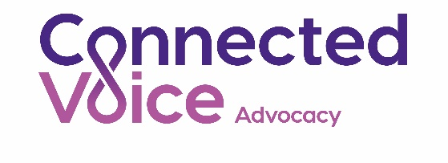

Connected Voice Advocacy
Independent Advocate
Contract Type | Permanent, & Sessional contracts available (all permanent posts are subject to project funding)
Hours | Variable - full, part time and sessional posts available  Up to full time (37 hours per week)
Application deadline | 12 noon on 14th July 2021
Interviews held: | 26th July 2021 via video conference
Based | Newcastle city centre/Home working during pandemic
Salary | £23,809- £27,269 - depending on experience and qualifications
Employer | Connected Voice

Connected Voice is a charity and the principal voluntary and community sector infrastructure organisation for Newcastle and Gateshead. Our mission is to support the development of voluntary and community action that is effective, sustainable and brings about positive social change. Connected Voice Advocacy (formerly Advocacy Centre North) is a service delivered by the charity and provides a free, independent, high quality and ethical advocacy service.
We are seeking to recruit an Independent Advocate to join our highly motivated and experienced team. We provide high quality, independent advocacy to support adults with a range of health and social care needs to enable them to take action to say what they want, secure their rights, represent their interests and obtain services they need.
Independent Advocates can support both community and statutory advocacy services, providing a range of advocacy services in relation to health and social needs under the Mental Health, Mental Capacity and Care Acts and/or advocate for adults in the community in vulnerable circumstances.

To find out more about this post download a recruitment pack from:
www.connectedvoice.org.uk/jobs
- Closing date for receipt of application forms is 12.00 noon on 14th July 2021
- Interviews will be held on 26th July 2021 via video call
- Please note that CVs will not be accepted
Connected Voice is an equal opportunities employer
Registered charity: 1125877
Company registration: 6681475

