World Car Free Day 2026

Community Fund Applicant’s Guide

Leave the car. Love the city.

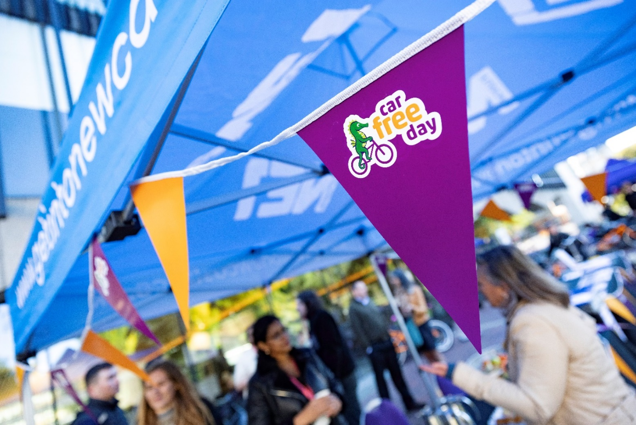

Join the movement towards a cleaner, healthier and more active Newcastle...
Newcastle is celebrating World Car Free Day this September. We are encouraging all communities across this city to join us.
World Car Free Day is an international day of celebration, falling on the 22nd of September. This unique event provides an opportunity to bring people together, promoting health, wellbeing, connectivity, and community.
Newcastle City Council is offering a maximum of £1000 to support communities and community organisations to mark the day in their locality. Please see the below information to apply.
For more information join our webinar which will go through the key information and provide an opportunity for questions or queries to be answered.
15th July: 16:00-16:45 Join meeting here
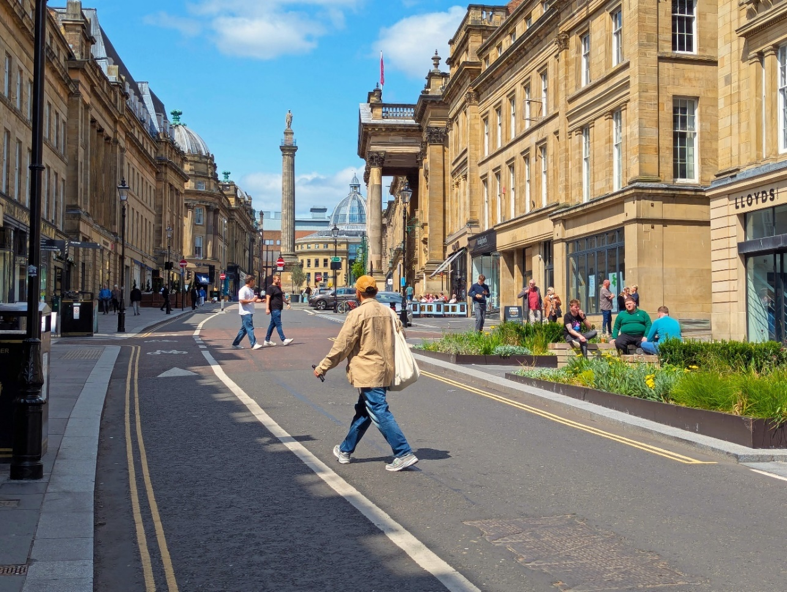
17th July: 12:00-12:45 Join meeting here

Who can apply
Eligible applicants include:
- Community and voluntary sector organisations
- Charities, CICs and community associations
- Organisations managing community buildings or spaces that are accessible to
- the public
To apply you must:
- Must be based within the Newcastle boundary.
- Have a written constitution or aims and objectives or a management committee for the organisation.
- Have a bank account in the name of the organisation, we cannot make payments to personal bank accounts.

Objectives of the fund
This project is to positively encourage communities to celebrate World Car Free Day. Through funding, we aim to help communities minimise car usage in local area – even if only for a day.
Rather than banishing cars for the day, this initiative seeks to empower communities to explore other options of transport and help uncover the benefits of reducing car usage and increasing physical activity.
In Newcastle not everyone has the same chances to be active or get around easily. Many people may feel lonely, struggle with their mental health or don't feel connected with their local area and green spaces. Green spaces can help by offering safe welcoming spaces where people can be active, spend time outdoors and be part of their local community.
We wish to support community groups that are already doing great work to improve wellbeing in their community. This includes helping them with activities that support being active, getting around more easily and taking part in cultural and nature-based activities.
This project aims to give residents more say and help them take a more active role in their community. It provides an opportunity for funded initiatives promoting walking, wheeling, and broader transport related incentives and workshops.
Key priorities of the fund:
- Support communities to explore sustainable and healthier travel options and support residents to minimise overall car usage where possible and practical.
- Create a long-term behaviour shift in healthier and sustainable ways of travel.
- Building stronger communities and promoting a feeling of neighbourliness.
- Increase pride of place and give residents a feeling of ownership and empowerment within their local community.

Examples of projects are we looking to fund
Activities to run active travel initiatives
- Bike and scooter repair pop-ups.
- Second hand bike giveaways. We plan to collect bikes across the city from large organisations and repurpose them. These can be distributed out to communities through organisations.
- Try Cycling initiatives: initiatives for those who want to try a bike or an electric bike.
- Group bike rides.
- Community Wellbeing walks.
- Bike maintenance classes where residents can learn basic repair techniques for bikes and scooters.
- Smoothie bike – where pedal power blends a smoothie.
- Adaptive cycling and wheeling workshops and trails.
- Wellbeing walks accommodating visually impaired and hearing-impaired communities.
- Active travel and public transport give aways. This could include pop cards, bike locks or information leaflets around public and active travel routes. (For support on this please get in contact)
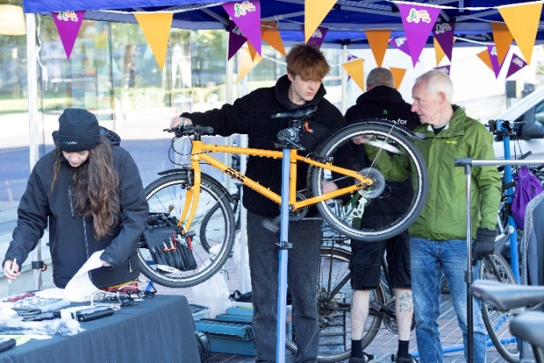
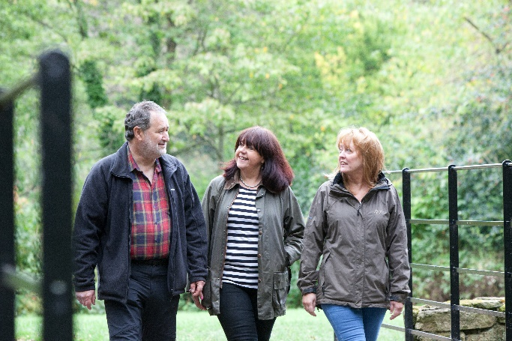

Wider community-based activities to set up in your local area:
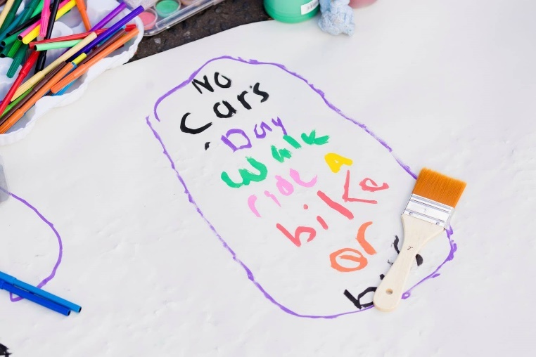
- Set up a parklet. This is when you transform parking spots into a place the whole community can use. They are temporary small green spaces providing space for people to come together and sit and chat. This will require permission from the Council.
- Local wellness fair
- Food stalls
- Art installation and workshops celebrating sustainable travel
- Space for bikes and scooters
- Ball games
- Giant jenga/chess
- Seating
- Music
- Dancing
- Planting activities and nature workshops connecting communities to nature and the outdoors.
Case Study: Dwellbeing
Dwellbeing Shieldfield marked World Car Free Day by holding a community filled with gardening, games, and performances for residents to enjoy. It was organised by Dwellbeing and Shieldfield Art works and supported by volunteers and organisations around the local Shieldfield area.
It was created as a local community event, held on the afternoon of the following weekend. The event offered free food and refreshments, music performances, crafts, gardening activities and games. and bike and scooter trails and maintenance. It also facilitated youth and community engagement into the neighbourhood, with children and young people creating signage advertising for safer streets and adults to discussing how to shape their neighbourhood.
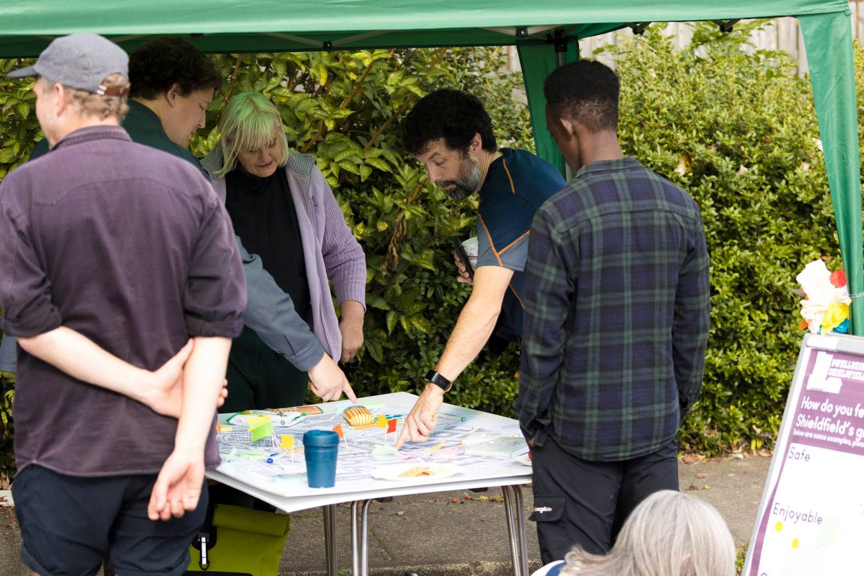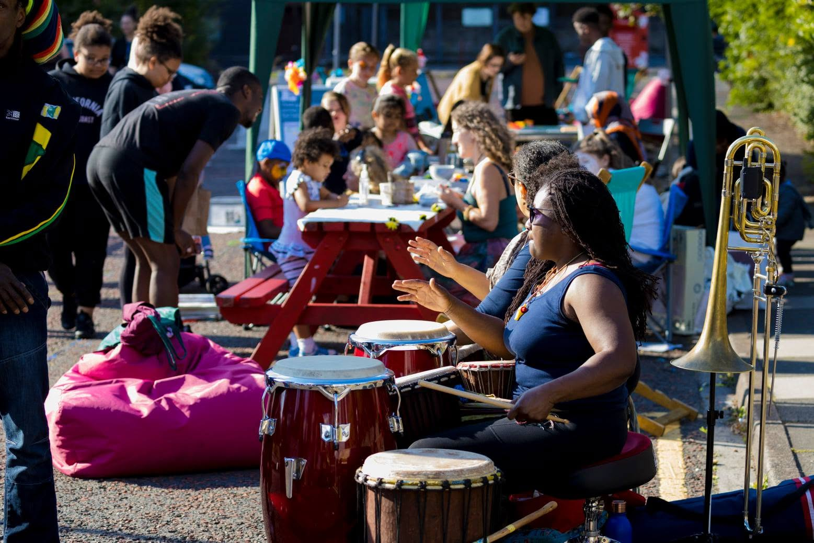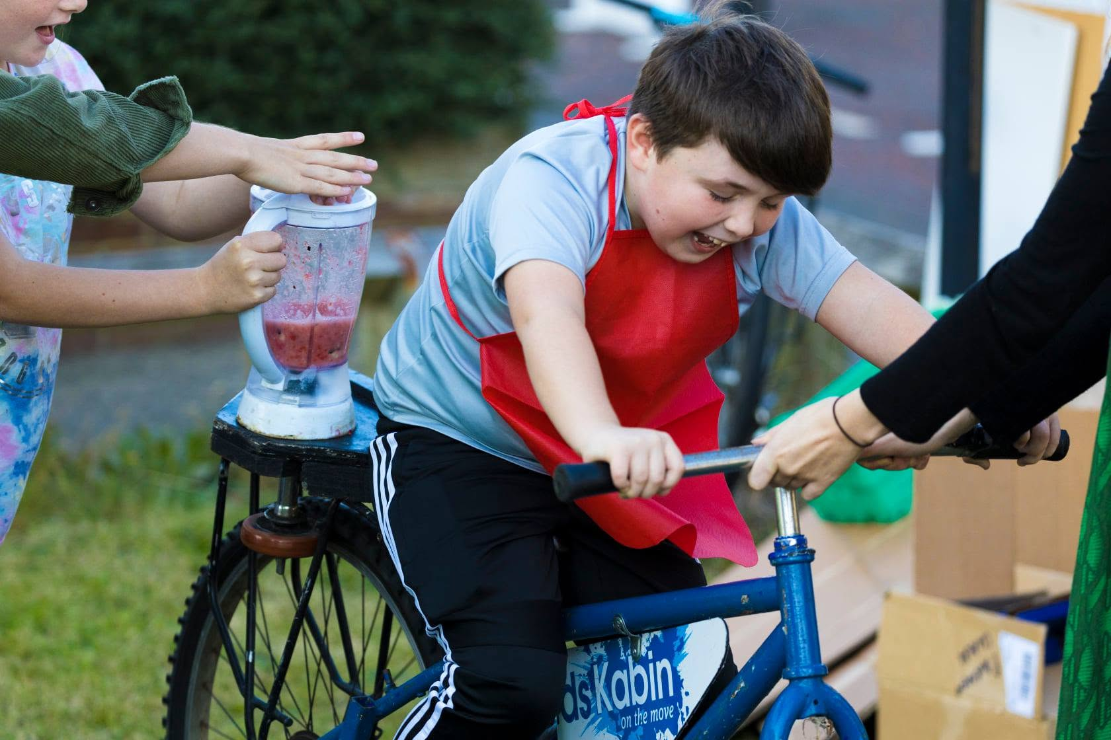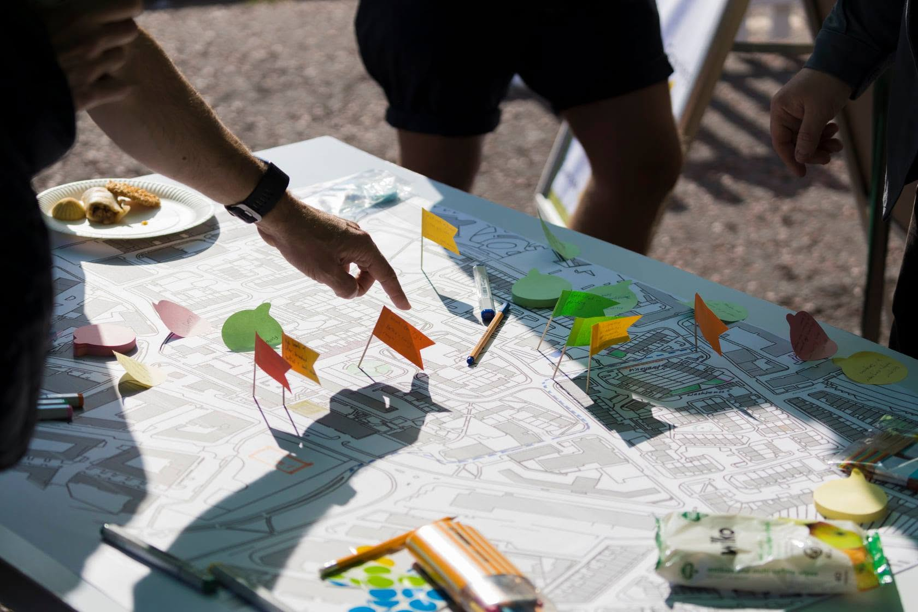
Image credit: Matthew Denham

How funding is decided
You will be asked to complete an application form which will be reviewed by Newcastle City Council’s Sustainability and Community Officer. They will check that your proposed project or event meets the fund’s objectives. Assuming it does, this will be scored and if scored highly funding will be allocated. You will then be invited to a meeting with Sustainability and Public Health officers to discuss your project. This will help answer any further questions and see if you need any further officer support for the event. We aim for this to be informal and relaxed and simply seeking to see how we can further support to ensure your World Car Far Day events are a success.
Fund Timeline
- Funding Applications open: 8th July
- Explainer webinar 15th July 4-4:45pm and 17th July 12-12:45pm
- Funding Application closing date: 24th July
- Initial meeting: Completed by August
- Event to be completed by September

FAQs
- Can I apply for a street closure?
Closing streets are largely unfeasible in this years World Car Free Day celebrations.
If you wish to apply for a temporary street closure for an event which will be extended beyond the residents of that specific street you must apply for a Temporary Traffic Regulation Order (TTRO). Each application takes 12 weeks to process so note this will need to be submitted 12 weeks prior to the event taking place.
Therefore, for celebrations and events planned in September it won’t be feasible for a road closure to be accepted.
You can apply for a street party, but events will only be able to be advertised to the residents of that specific street. Applications risk getting rejected if it appears the event will be advertised to the wider community.
For more information visit:
https://new.newcastle.gov.uk/travel/apply/roadclosure
- Do we need to mark the day on the 22nd of September or can I run a weekend event?
No, there is no expectation to run community events on World Car Free Day itself. We recommend exploring a weekend day or afternoon either prior or following the 22nd. However, each community is able to choose a date and time which best accommodates their residents.
- How to request a temporary closure of a parking space to set up a parklet?
To request a temporary suspension of a parking place please specify this on your application and we can support further with this request if the application receives funding.

